

MS Word Training- Session-4: Part-2

Track Changes & Template usage
Version: 1.0
February 2009
Copyright Information:
This document is the sole property of AIG Inc. All rights reserved. No part of this document may be reproduced, stored in a retrieval system, translated, transcribed, or transmitted in any form or by any means, without the prior written permission of AIG Systems Solutions (AIGSS).
Document Information
S.No | Document Title | Base Version No. | Author | Contact Email ID | Date Of Release
1 | MS Word Training Session 4 – Part 2 Track Changes and Template usage | 1.0 | Deepika Datta | deepika.datta@aig.com | February 2009
Revision History
S.No | Version No. | Date Of Release | Author (s) | Affected Section(s) | History of Changes | Approver

Table of Contents
1 Reviewing using Track changes 4
1.1 Introduction 4
1.2 Tracking Changes 4
1.3 Comments 5
1.4 Distinguishing Reviewers' Changes 5
1.5 Reviewing Revisions 5
1.5.1 Accepting or Rejecting All 5
1.5.2 Accept or Reject Individual Revisions 5
1.6 Reviewing Pane 6
1.6.1 To Display the Reviewing Pane 6
1.6.2 Turning Off Track Changes 6
1.7 Locking a Document 6
1.8 Comparing Documents 6
2 Versions 7
2.1 Viewing Version Information 7
2.2 Saving a Version 7
2.3 Deleting a Version 7
2.4 Automatically Saving a Version on Close 7
2.5 Opening an Earlier Version of a Document 7
2.6 Saving an Earlier Version as a Separate File 7
3 Checklist for using AIGSS Word Template 8
3.1 Header & Footer 8
3.2 Different levels of Headings 8
3.3 Table of contents 8
3.4 Bullets and Numbering 8
3.5 Tables 8
3.6 Style for the document 8
3.7 Single Page Documents 8

Reviewing using Track changes

Introduction
The Track Changes facility allows a person who is proof reading a document to mark all their suggested additions and deletions on-screen, for example, additions can be underlined and deletions struck through. The document can then be proofed further and the appropriate corrections ultimately removed or added. This is more efficient than marking revisions on a paper copy which then have to be typed in. It is also more economic as the document need only be printed when the final version is ready.
If more than one person makes revisions to a document, their revision marks will be displayed in a different color. Also when you come to either accept or reject the revisions, Word displays who made the revision and on what date.

Tracking Changes
To set up a document to track changes:
Track Changes

New Comment
Accept Changes
- From the Tools menu select Track Changes.
- To start using the track changes, click on the Track Changes button on the toolbar.
Once you begin to edit the document, by default any comments, insertions or deletions and formatting changes will be displayed on the screen.
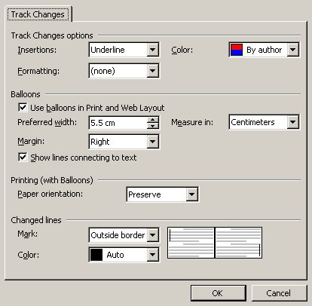
- To remove any of these options from the screen, click on the Show drop down list and click on the appropriate option.
- To specify how the revisions will be marked, click on the Show drop down and click on Options. The Track Changes dialogue box will appear.
- Inserted text will, by default, be underlined. You can change this to no formatting, colour only, bold, italic, underline or double underline.
- For Inserted and Deleted Text, the colour of both types of revisions will be specific to the Author - the person making the revision.
- Formatting changes can also be tracked and marked with colour only, bold, italic, underline or double underline.
- A description of the formatting applied and the text deleted appear in balloons, by default, in the right hand margin. To change the position of the balloon, click on the Margin drop down. The balloons can appear in the left or right hand margin. The size of the balloons can be adjusted using the preferred width option.
- When you make revisions, a vertical line is displayed next to the line containing the revision. Use the show lines connected to text check box to specify whether you want a line. If you do, choose where to position it (to the left or right of the paragraph, or as an outside border) from the Changed Lines Mark drop down. The colour of the line can be changed from the Changed Line Colour drop down.
- Click on Ok to confirm your changes.

Comments
Comments can be inserted into the word document and will appear in the right hand margin.
To insert a comment:
- Select the text or item you want to comment on or click at the end of the text. Click on the New Comment button drop down and select New Comment
- The new comment will appear in a balloon in the right hand margin. The cursor will be active in the comment balloon, ready for you to add your comment.
To edit a comment:
- click into the comment balloon and make your edit.
To delete a comment:
- Select the comment and click on the New Comment drop down, select Delete Comment.

Distinguishing Reviewers' Changes
Word assigns a different colour to each reviewer. If there are more than eight reviewers, Word recycles the colours.
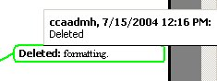
To assign a particular colour to yourself, click on Show drop down on the Reviewing topbar, and then click on options. From the Colour drop down, click the colour with which you want to display your proposed changes.
Word identifies reviewers by name or initial When you rest the mouse pointer on a change, Word displays in a ScreenTip the name of the reviewer, the date and time the change was made, and the type of change (for example, Deleted).
If the reviewer information doesn't appear above the change, click Options on the Tools menu, click the View tab, and then select the ScreenTips check box. If something other than the reviewer's initials appears (for example, "Initials1"), your reviewer might not have identified himself or herself on the User Information tab. You can ask all reviewers to add their initials so that the initials appear above suggested changes and in comments.

Reviewing Revisions
When you open a document that contains revision marks, you can either continue to make more revisions, or review the current revisions - accepting, rejecting or leaving them for later.
To review revision marks:
- The reviewing toolbar should already be opened. If not, click on the Tools menu and click on Track Changes.
- A list of all reviewers can be accessed from the Show drop down. To remove an authors markup, click on the Show drop down, select Reviewers and click on the author’s name from the sub-menu. To remove all reviewers markup, select All reviewers from the Reviewers sub-menu.

Accepting or Rejecting All
Accepting and rejecting all revisions is done via the reviewing toolbar. The Accept Change button and the Reject change/delete comment button enables you to Accept All or Reject All revisions in one go from the corresponding drop downs.
If you choose Yes and then decide this was a mistake, you can still Undo this action, simply click on the Undo button.

Accept or Reject Individual Revisions
To accept or reject individual revisions, select the revision and click on the corresponding drop down. Click on the appropriate Find button to find the next or previous revision in your document.
When you either accept or reject, you can click on the Undo button if you change your mind about the last revision.

Reviewing Pane
Microsoft Word cannot always display the complete text of a tracked change or comment in a markup balloon. To see these items, and to see items such as inserted or deleted graphics or text boxes, use the Reviewing Pane.
The Reviewing Pane will appear at the bottom of screen and gives a description of what was deleted, inserted or changed, the reviewers name, the date and time.

To Display the Reviewing Pane
- On the Reviewing toolbar, click on the Reviewing Pane.

Turning Off Track Changes
To continue editing as normal without marking the changes, you need to turn track changes off.
To switch Track Changes off:
- From the reviewing toolbar, click on the Track Changes button on the toolbar. This button enables you to toggle between normal editing and track changes mode.

Locking a Document
If you save a file with the Track Changes switched on, then any other person who opens the file will automatically be marking revisions when they edit the text. They could, however, turn off the Track Changes and edit as normal.
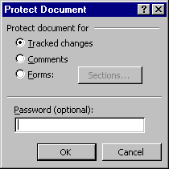
To prevent someone from turning the Track Changes feature off, you would need to lock the document. You can also include a password, so that only users who know the password can then unlock the document and turn off the Track Changes. The original author would still be able to edit the document and accept or reject the revisions.
- From the Tools menu , select Protect Document.
- Click on the Tracked changes radio button, and add a Password if required.
- Click on OK.
To unlock a protected document:
- From the Tools menu, select Unprotect Document
- You will be prompted to enter the password if one has been added.

Comparing Documents
- Open the edited copy of the document.
- From the Tools menu, click on Compare and Merge Documents.
- Open the original document.
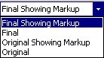
- The review drop down list enables you to see the file with final markup, the final version [no markup shown], the original showing mark up and the original copy of the document [no markup shown].
Helpful Hint:
If you've used the Versions command on the File menu to save multiple versions of the document in one file, and you want to compare the current version with an earlier one, you must first save the earlier version as a separate file under a different name.

Versions
You are able to maintain a working history of a document. With this feature, you can see exactly who did what on a document and when. All the versioning information is stored within the document, so you don't need to maintain and track multiple copies of a document.

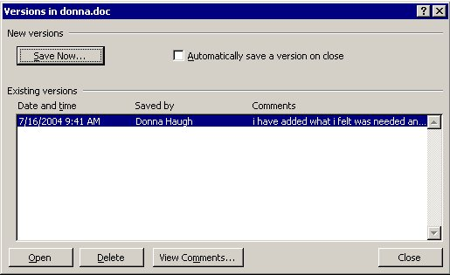
Viewing Version Information
From the File menu, select Versions.
Word displays the date and time each version was saved, the name of the person who saved each version, and truncated lines of comments. The most recent version appears at the top of the list.
To see the complete comments about a particular version, click the version, and click View Comments.

Saving a Version
- From the File menu, select Versions.
- Click on the Save Now button and enter any comments into the dialog box.
- You or any other editor of the document will have to choose Versions from the File menu to save a new version.

Deleting a Version
- From the File menu, select Versions.
- Click on the version you want to delete.
- Click Delete

Automatically Saving a Version on Close
- From the File menu, select Versions.
- Select the Automatically save a version on close check box.
- Click Close.

Opening an Earlier Version of a Document
- From the File menu, select Versions.
- Select the version of the document you want to open.
- Click Open.
- Your screen will be split in two, with the earlier version displayed in the lower half of the screen.

Saving an Earlier Version as a Separate File
- On the File menu, click Versions.
- Click the version of the document you want to save as a separate file.
- Click Open.
- On the File menu, click Save As.
- In the File name box, enter a name, and then click Save.
Helpful Hint: If you want to Compare one version of a document with another version of the same document, you will need to save one of the versions as a separate file.

Checklist for using AIGSS Word Template
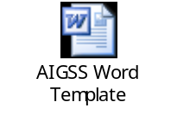

Header & Footer
- Do not tamper with the left side heading in the header, it is automatically generated according to the first level heading of that page
- Only change the text on the right hand side in the angular brackets to the title of the document
- Only change the version in the footer. Page numbers are automatically generated.

Different levels of Headings
- Avoid using more than 3 levels of headings
- Use ctrl+alt+1 for heading 1
- Use ctrl+alt+2 for heading 2
- Use ctrl+alt+3 for heading 3
- Use Text heading styles for other sub headings under these styles

Table of contents
- Do not type the table of contents at the start, it is automatically generated
- First finish with the rest of the document
- Right click on the Table of Contents and select Update fields, the table is automatically generated

Bullets and Numbering
- Always use the List number styles for numbered lists and the list bullet styles for the bulleted list

Tables
- Use the AIGSS table1 styles for inserting tables
- The color of the first/heading row should be RGB (0, 48,101)
- The width of the table should be 6.5”.
- The styles used for the Header row is the Whitetablehead style
- The style used for other cells in the table should be either Table body or text in table style

Style for the document
- Use body text style instead of normal style for the text in the document
- The font to be used is Garamond.
- Use strong style where you need the text to be bold
- Use emphasis style where you need the text to be in italics

Single Page Documents
- Use the template for single page document. 